TASK 3 – TICKET BOOKING SYSTEM

(Aggregate functions, Having, Order By, GroupBy and Joins)

1. Write a SQL query to List Events and Their Average Ticket Prices.

mysql> SELECT event_id, event_name, available_seats, event_type, venue_id, booking_id, AVG(ticket_price) FROM Event GROUP BY event_id

, event_name;

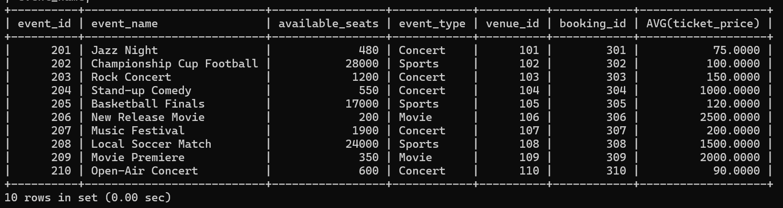

1. Write a SQL query to Calculate the Total Revenue Generated by Events.

mysql> SELECT SUM(b.num_tickets * e.ticket_price) AS total_revenue

-> FROM Booking b

-> INNER JOIN

-> Event e ON b.event_id = e.event_id;

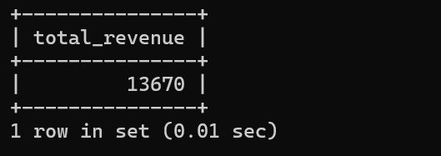

1. Write a SQL query to find the event with the highest ticket sales.

mysql> SELECT e.event_name, e.event_id, b.num_tickets FROM Event e INNER JOIN Booking b ON e.event_id = b.event_id ORDER BY num_ticke

ts DESC;

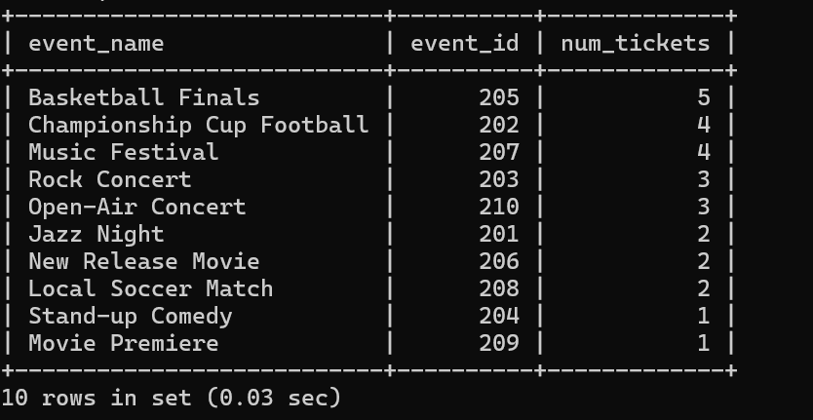

1. Write a SQL query to Calculate the Total Number of Tickets Sold for Each Event.

mysql> SELECT DISTINCT e.event_id, e.event_name, SUM(b.num_tickets) AS Total_Tickets FROM Event e INNER JOIN Booking b ON e.event_id

= b.event_id GROUP BY e.event_id, e.event_name;

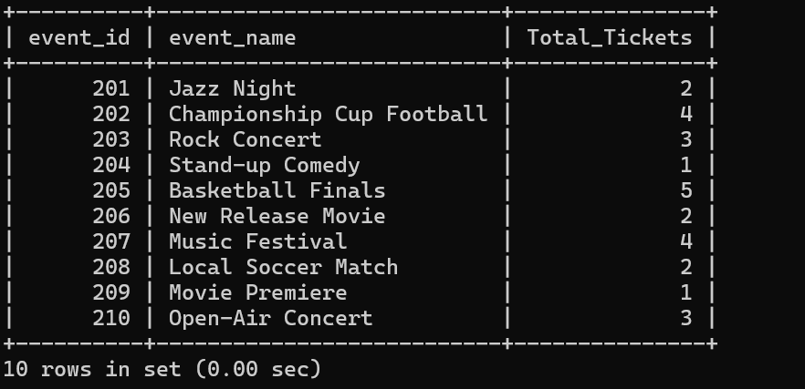

1. Write a SQL query to Find Events with No Ticket Sales.

mysql> SELECT COUNT(*)

-> FROM Event e

-> LEFT JOIN Booking b ON e.event_id = b.event_id

-> WHERE b.event_id IS NULL;

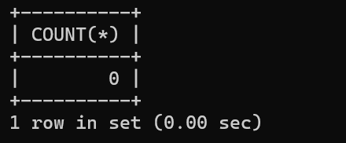

1. Write a SQL query to Find the User Who Has Booked the Most Tickets.

mysql> SELECT c.customer_id, c.customer_name, SUM(b.num_tickets) AS total_tickets

-> FROM Customers c

-> INNER JOIN Booking b ON c.customer_id = b.customer_id

-> GROUP BY c.customer_id, c.customer_name

-> ORDER BY total_tickets DESC;

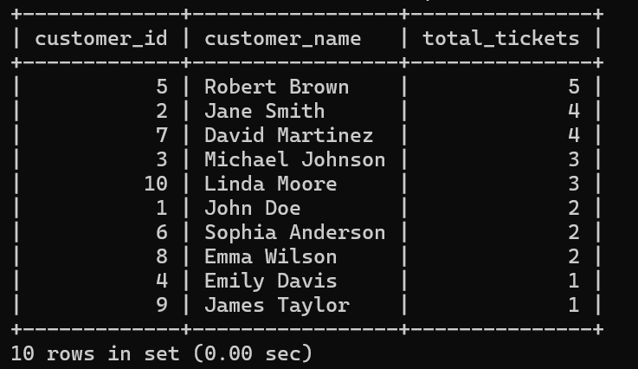

1. Write a SQL query to List Events and the total number of tickets sold for each month.

mysql> SELECT e.event_id, e.event_name, MONTH(b.booking_date) AS month,SUM(b.num_tickets) AS total_tickets

-> FROM Event e INNER JOIN Booking b ON e.event_id = b.event_id

-> GROUP BY e.event_id, e.event_name, MONTH(b.booking_date)

-> ;

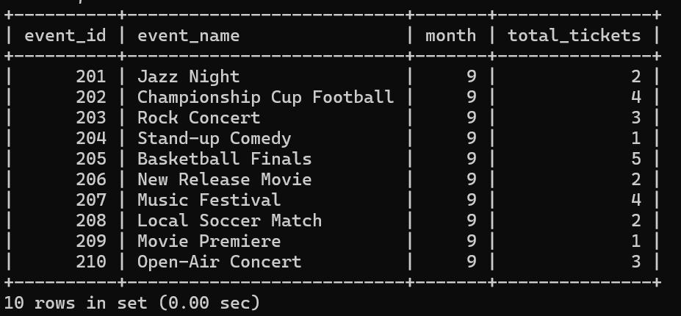

1. Write a SQL query to calculate the average Ticket Price for Events in Each Venue.

mysql> SELECT v.venue_id, v.venue_name, AVG(e.ticket_price) AS avg_ticket_price

-> FROM Venu v INNER JOIN Event e

-> ON v.venue_id = e.venue_id

-> GROUP BY v.venue_id, v.venue_name;

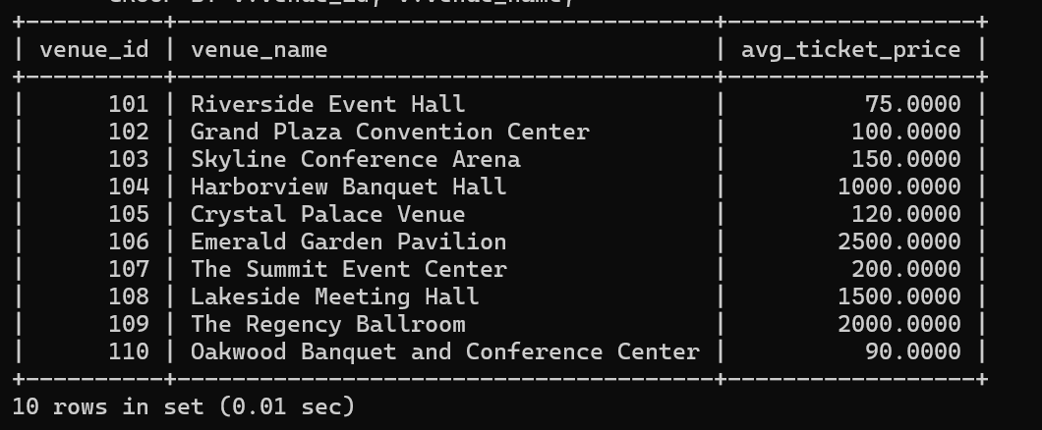

1. Write a SQL query to calculate the total Number of Tickets Sold for Each Event Type.

mysql> SELECT

-> e.event_type,

-> SUM(b.num_tickets) AS total_tickets_sold FROM Event e JOIN

-> Booking b ON e.event_id = b.event_id

-> GROUP BY

-> e.event_type

-> ORDER BY

-> total_tickets_sold DESC;

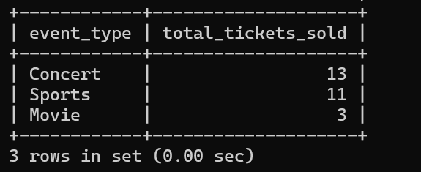

1. Write a SQL query to calculate the total Revenue Generated by Events in Each Year

mysql> SELECT

-> YEAR(b.booking_date) AS year,

-> SUM(b.num_tickets * e.ticket_price) AS total_revenue FROM

-> Booking b JOIN Event e ON b.event_id = e.event_id

-> GROUP BY

-> YEAR(b.booking_date)

-> ORDER BY

-> YEAR(b.booking_date);

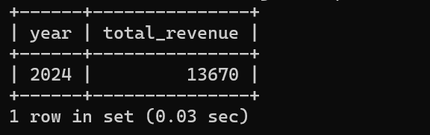

11. Write a SQL query to list users who have booked tickets for multiple events.

mysql> SELECT c.customer_id, c.customer_name, COUNT(b.event_id) AS event_count FROM Customers c INNER JOIN Booking b ON c.customer_id = b.customer_id GROUP BY c.customer_id, c.customer_name HAVING event_count > 1;

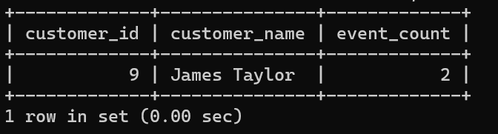

12. Write a SQL query to calculate the Total Revenue Generated by Events for Each User.

mysql> SELECT c.customer_id, c.customer_name, SUM(b.num_tickets * e.ticket_price) AS total_revenue FROM Customers c INNER JOIN Booking b ON c.customer_id = b.customer_id INNER JOIN Event e ON b.event_id = e.event_id GROUP BY c.customer_id, c.customer_name ORDER BY total_revenue DESC;

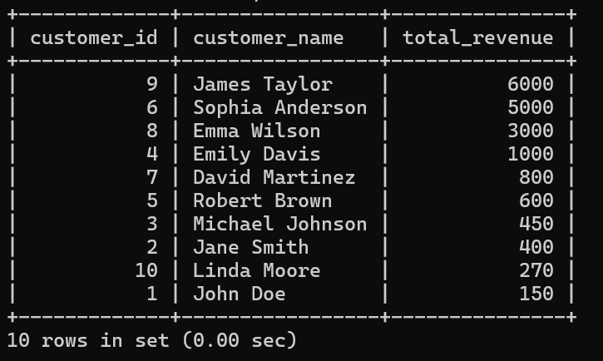

13. Write a SQL query to calculate the Average Ticket Price for Events in Each Category and Venue.

mysql> SELECT e.event_type, v.venue_name, AVG(e.ticket_price) AS Avg_ticket_price FROM Event e INNER JOIN Venu v ON e.venue_id = v.venue_id

-> GROUP BY e.event_type, v.venue_name ORDER BY e.event_type, v.venue_name;

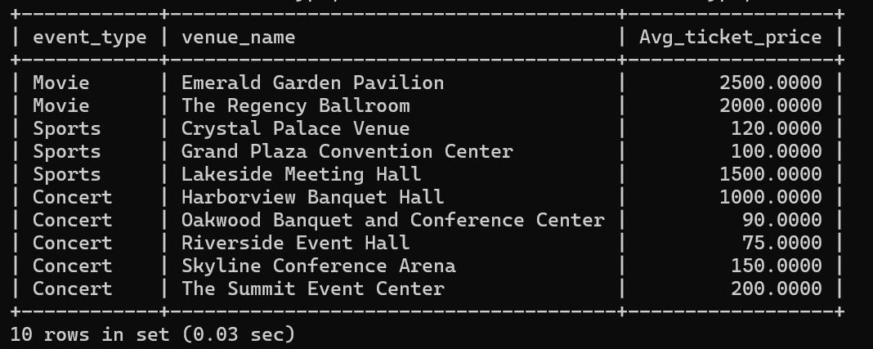

14. Write a SQL query to list Users and the Total Number of Tickets They've Purchased in the Last 30 Days

mysql> SELECT c.customer_id, c.customer_name, SUM(b.num_tickets) AS total_tickets_purchased FROM Customers c INNER JOIN Booking b ON c.customer_id = b.customer_id WHERE b.booking_date >= CURDATE() - INTERVAL 30 DAY

-> GROUP BY c.customer_id, c.customer_name

-> ORDER BY total_tickets_purchased DESC;

